 جامعة الأزهر

كلية الهندسة بالقاهرة – بنات

قسم هندسة النظم والحاسبات

بحث مقدم من

اسم الطالب : دينا علاء الدين السيد محمد

الرقم الجامعى : 413121

اسم المقرر :مجسات ومحولات قدرة

كود المقرر : نظم 310

عنوان البحث : ADC(analog to digital converter)

بإشراف

اسم المشرف : دكتور على راشد

**Abtract about ADC (analog to digital converter):**

Analog-to-Digital Converters (ADCs) are critical components of biomedical, communications and signal processing

systems which require low power consumption and high conversion efficiency and are used to convert the real world signal to digital signal for the purpose of processing, In this paper various state-of-the-art ADC's including experimental converters, have been explored keeping in mind their application requirements. A comparative study of these ADC's, keeping in mind the various performance parameters like power consumption, resolution, sampling rate has also been presented, providing an insight into their shortcomings.

***End abstract…..***

from [<https://www.researchgate.net/publication/312572000_Analog-to-digital_converters_A_comparative_study_and_performance_analysis>]

**introduction about ADC (analog to digital converter):**

- The signals in the real world appear in analog domain but transmission of digital data is carried in digital domain, since signals are classified as analog and digital, based on this relevance systems are portioned as analog and digital. Partitioning of system into analog and digital is based on certain specification of signal such as their frequency. For the bandwidth of above 10MHz, signal are processed in analog domain; for the bandwidth below 100Hz, signals are processed in digital domain; and for the signal lying in the range of 100Hz to 10MHz there is a trade-off between accuracy and flexibility of digital approach and cost, power and size of analog approach. Based on whether the subsystem works efficiently in analog or in digital domain.

- Data Converters are devices that convert analog signals to digital domain and vice versa. Data Converters form the critical components of all the systems. Data Converters can be implemented in a number of ways each having a different performance in terms of resolution, speed, power consumption, area, etc.

- Analog-to-digital converters are a class of data converters with one way conversion from Analog-to-Digital domain. The implementation of ADC‟s is usually done either as serial or parallel converters…

***End introduction…..***

from [<https://www.researchgate.net/publication/312572000_Analog-to-digital_converters_A_comparative_study_and_performance_analysis>]

**the subject:**

Firstly :

**what is analog to digital conversion?**

-It’s a process of capturing the analog electric signal (such as sound captured by a microphone) and converting it to a series of numeric “Digital” values to be stored/processed by a digital computer or DSP. The electronic device which is used for this conversion process has been known to be the A/D or **ADC** (Analog-To-Digital Converter).

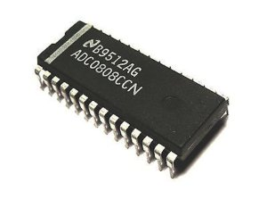

(Adc chip)

From [<https://deepbluembedded.com/analog-to-digital-converter-how-adc-work-pic/>]

Secondly :

**why we need analog to digital converters?**

-Our need to convert analog signals to digital data stems from the fact that our computers are digital ones. They just can’t handle the analog signal and therefore, there should be a device which converts the signal from analog to digital domain (ADC).

Most signals are analog in nature and the electronic sensors which we’re using for capturing these phenomena are also analog. For example, the temperature sensor converts temperature in °C to an analog voltage that’s proportional to the value of temperature. So do the microphone, pressure sensor, light sensor and so on.

Hence, we need a way to read analog voltage and convert it to digital values which we can program our computers to manipulate it mathematically in order to achieve real-time monitoring and/or control or whatever.

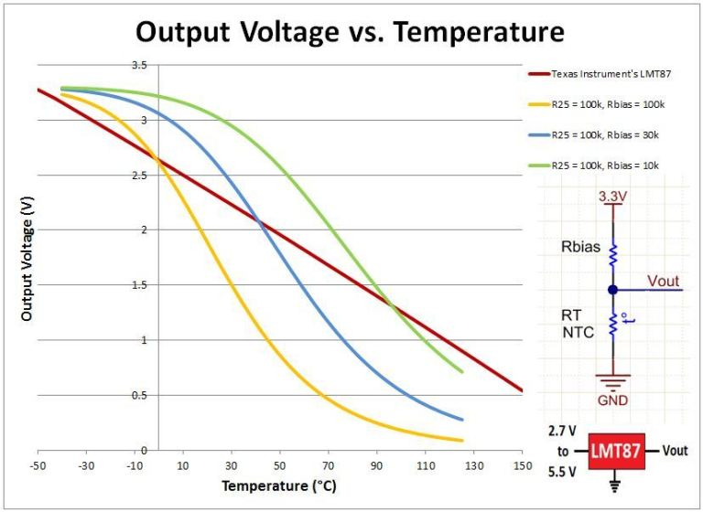

From [<https://deepbluembedded.com/analog-to-digital-converter-how-adc-work-pic/>]

Thirdly :

**How adc works?**

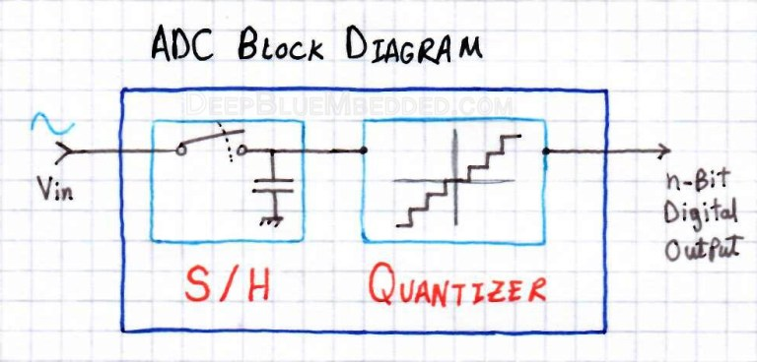

The basic structure of an ADC consists of an S/H circuit (Sample & Hold). Followed by a quantized which is actually the working horse for the analog to the digital conversion process. The type of ADC depends on how it’s performing the quantization process, it can be analog integration, digital counter, successive approximation, or even direct conversion as in Flash ADC types which we’ll discuss hereafter.

Finally, the digital output data is served to the CPU or gets directly stored in memory. The ADC can either be integrated within the MCU chip itself or a standalone IC that you can interface with Serial/Parallel ports of your microcontroller.

From [<https://deepbluembedded.com/analog-to-digital-converter-how-adc-work-pic/>]

Finally :

**different types of adc?**

1- Direct conversion or flash adc

For conversion of data into N-bit digital word, flash type of ADC uses M=2N

comparators and compares the fixed input

signal to a varying reference signal. The output of these comparators is fed to an M:N encoder to receive N-bit data at output. Since M number of comparators work simultaneously, hence also known as Parallel Analog-to Digital Converter.

This picture shows the 8-bit flash Analog-to Digital Converter. Flash or Parallel Analog-to Digital Converter is the simplest type of Data Converter and takes minimum time, a single cycle time to convert to convert the signal to digital form. Since less time implies more speed, it is suitable for applications requiring large bandwidth. The only limitation of Flash ADC is 2N comparators are used, due to which it becomes expensive and power inefficient.

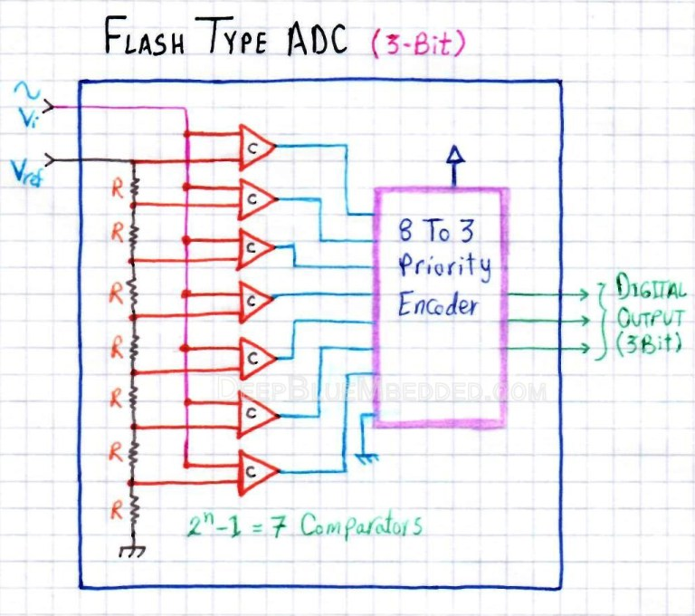

2- Ramp adc

* This type of Analog-to-Digital Converter consists of a comparator, an AND gate, digital counter and a DAC. Here the digital counter starts counting from zero. With each clock pulse the value of counter is increased by a step, converted back to analog form and compared to the analog input. Here AND gate acts as a control signal. The value of digital counter increases till it becomes equal to the sampled input. The final value is displayed at output.

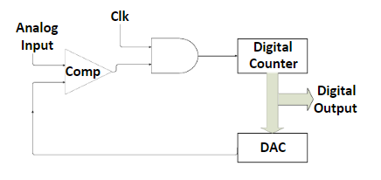

3- successive approximation adc

SAR ADC works on the same principle as that of Ramp ADC. However instead of using a digital counter starting at zero, it uses a synthetic approximation register that counts by trying all bits starting from MSB. Here the comparison is done by setting MSB „1‟ and all other bits „0‟ and thus the value of MSB is determined. In the next cycle 2nd MSB is set „1‟ and next bits “0‟ and the 2nd MSB is thus decided and so on. Figure 5 shows the block diagram of SAR ADC.



4- TIME INTERLEAVED ADC

- this type of architecture consists of a number of ADC‟s connected in parallels. The inputs to these ADC‟s are the clocked samples of Sample and Hold circuit. Here each sample is converted using different subsystem. It generally uses SAR‟s to do the conversion.

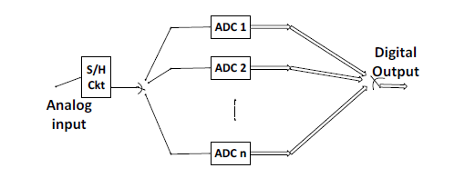

There are also many types of DSC's that we didn't talk about ,like

- Delta-encoded adc or counter-ramp

- Sigma-delta adc (also known as delta-sigma adc)

- Pipeline adc (also called subraring quantizer)

- Wilkinson adc

But we will remind them in conclusion.

*all types of ADC From [<https://www.researchgate.net/publication/312572000_Analog-to-digital_converters_A_comparative_study_and_performance_analysis>] ***End the subject…..***

**The conclusion**

* Various ADCs have been presented in this paper such as Flash ADC works with maximum speed but consumes large area and has low resolution, Counter type ADC‟s consume less area but their conversion time is max. Similarly, SAR can be used to attain ultra-low power at the cost of either resolution or speed, whereas Sigma Delta gets the maximum resolution and Dual Slope consumes minimum power. Hence there is a trade-off between various performance parameters like resolution, sampling speed, power consumption, area and others depending upon the application requirement.

***End the conclusion…..***

**References:**

* <https://www.researchgate.net/publication/312572000_Analog-to-digital_converters_A_comparative_study_and_performance_analysis>
* <https://deepbluembedded.com/analog-to-digital-converter-how-adc-work-pic/>